UNITED STATES
SECURITIES AND EXCHANGE COMMISSION
WASHINGTON, D.C. 20549

SCHEDULE 14A

Proxy Statement Pursuant to Section 14(a) of the
Securities Exchange Act of 1934
(Amendment No. )

Filed by the Registrant ☒

Filed by a Party other than the Registrant ☐

Check the appropriate box:

 | ☐ | Preliminary Proxy Statement

 | ☐ | Confidential, for Use of the Commission Only (as permitted by Rule 14a-6(e)(2))

 | ☐ | Definitive Proxy Statement

 | ☒ | Definitive Additional Materials

 | ☐ | Soliciting Material under §240.14a-12

CID HoldCo, Inc.
(Name of Registrant as Specified In Its Charter)

(Name of Person(s) Filing Proxy Statement, if other than the Registrant)

Payment of Filing Fee (Check the appropriate box):

 | ☒ | No fee required.

 | ☐ | Fee paid previously with preliminary materials.

 | ☐ | Fee computed on table in exhibit required by Item 25(b) per Exchange Act Rules 14a-6(i)(1) and 0-11.

SUPPLEMENT TO THE PROXY STATEMENT
FOR THE ANNUAL MEETING OF STOCKHOLDERS
TO BE HELD ON MAY 12, 2026

CID HoldCo, Inc. (the “Company”) is filing the attached revised proxy card as an amendment to the Definitive Proxy Statement on Schedule 14A that was filed by the Company with the Securities and Exchange Commission (the “SEC”) on April 17, 2026 (the “Proxy Statement”). After filing the Proxy Statement, the Company discovered that the form of proxy card filed with the Proxy Statement included certain scrivener’s errors.

The revised proxy card has been made available to the Company’s stockholders in the form attached hereto as Appendix A.

Please note that no changes have been made to the body of the Proxy Statement. This Form DEFA14A is being filed solely to revise the EDGAR version of the Proxy Statement to correct the form of proxy card.

APPENDIX A
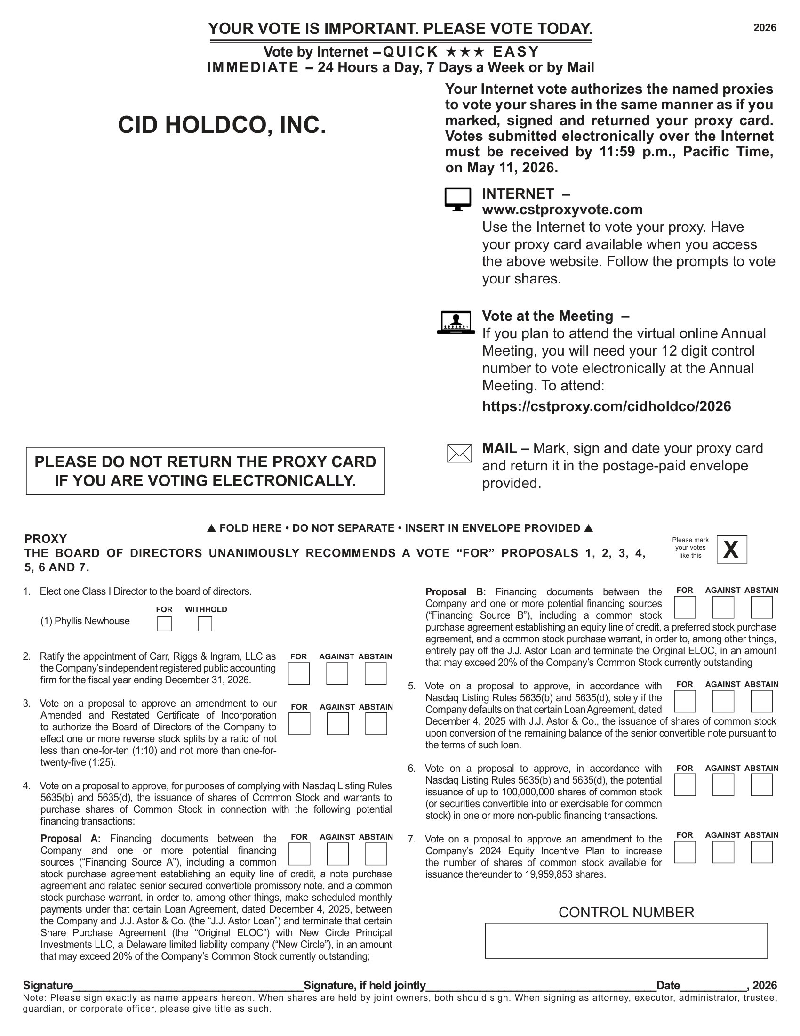
2026 CID HOLDCO, INC. Signature Signature, if held jointly Date , 2026 Note: Please sign exactly as name appears hereon. When shares are held by joint owners, both should sign. When signing as attorney, executor, administrator, trustee, guardian, or corporate officer, please give title as such. Please mark your votes like this X PROXY THE BOARD OF DIRECTORS UNANIMOUSLY RECOMMENDS A VOTE “FOR” PROPOSALS 1, 2, 3, 4, 5, 6 AND 7. CONTROL NUMBER FOLD HERE • DO NOT SEPARATE • INSERT IN ENVELOPE PROVIDED Proposal B : Financing documents between the Company and one or more potential financing sources (“Financing Source B”), including a common stock purchase agreement establishing an equity line of credit, a preferred stock purchase agreement, and a common stock purchase warrant, in order to, among other things, entirely pay off the J . J . Astor Loan and terminate the Original ELOC, in an amount that may exceed 20 % of the Company’s Common Stock currently outstanding 5 . Vote on a proposal to approve, in accordance with Nasdaq Listing Rules 5635 (b) and 5635 (d), solely if the Company defaults on that certain Loan Agreement, dated December 4 , 2025 with J . J . Astor & Co . , the issuance of shares of common stock upon conversion of the remaining balance of the senior convertible note pursuant to the terms of such loan . 6 . Vote on a proposal to approve, in accordance with Nasdaq Listing Rules 5635 (b) and 5635 (d), the potential issuance of up to 100 , 000 , 000 shares of common stock (or securities convertible into or exercisable for common stock) in one or more non - public financing transactions . 7 . Vote on a proposal to approve an amendment to the Company’s 2024 Equity Incentive Plan to increase the number of shares of common stock available for issuance thereunder to 19 , 959 , 853 shares . 2 . Ratify the appointment of Carr, Riggs & Ingram, LLC as the Company’s independent registered public accounting firm for the fiscal year ending December 31 , 2026 . 3 . Vote on a proposal to approve an amendment to our Amended and Restated Certificate of Incorporation to authorize the Board of Directors of the Company to effect one or more reverse stock splits by a ratio of not less than one - for - ten ( 1 : 10 ) and not more than one - for - twenty - five ( 1 : 25 ) . 4 . Vote on a proposal to approve, for purposes of complying with Nasdaq Listing Rules 5635 (b) and 5635 (d), the issuance of shares of Common Stock and warrants to purchase shares of Common Stock in connection with the following potential financing transactions : Proposal A : Financing documents between the Company and one or more potential financing sources (“Financing Source A”), including a common stock purchase agreement establishing an equity line of credit, a note purchase agreement and related senior secured convertible promissory note, and a common stock purchase warrant, in order to, among other things, make scheduled monthly payments under that certain Loan Agreement, dated December 4 , 2025 , between the Company and J . J . Astor & Co . (the “J . J . Astor Loan”) and terminate that certain Share Purchase Agreement (the “Original ELOC”) with New Circle Principal Investments LLC, a Delaware limited liability company (“New Circle”), in an amount that may exceed 20 % of the Company’s Common Stock currently outstanding ; PLEASE DO NOT RETURN THE PROXY CARD IF YOU ARE VOTING ELECTRONICALLY. marked, signed and returned your proxy card . Votes submitted electronically over the Internet must be received by 11 : 59 p . m . , Pacific Time, on May 11 , 2026 . INTERNET – www.cstproxyvote.com Use the Internet to vote your proxy. Have your proxy card available when you access the above website. Follow the prompts to vote your shares. Vote at the Meeting – If you plan to attend the virtual online Annual Meeting, you will need your 12 digit control number to vote electronically at the Annual Meeting. To attend: https://cstproxy.com/cidholdco/2026 MAIL – Mark, sign and date your proxy card and return it in the postage - paid envelope provided. YOUR VOTE IS IMPORTANT. PLEASE VOTE TODAY. Vote by Internet - QUICK YYY EASY IMMEDIATE - 24 Hours a Day, 7 Days a Week or by Mail Your Internet vote authorizes the named proxies to vote your shares in the same manner as if you FOR AGAINST ABSTAIN 1. Elect one Class I Director to the board of directors. FOR WITHHOLD (1) Phyllis Newhouse FOR AGAINST ABSTAIN FOR AGAINST ABSTAIN FOR AGAINST ABSTAIN FOR AGAINST ABSTAIN FOR AGAINST ABSTAIN FOR AGAINST ABSTAIN

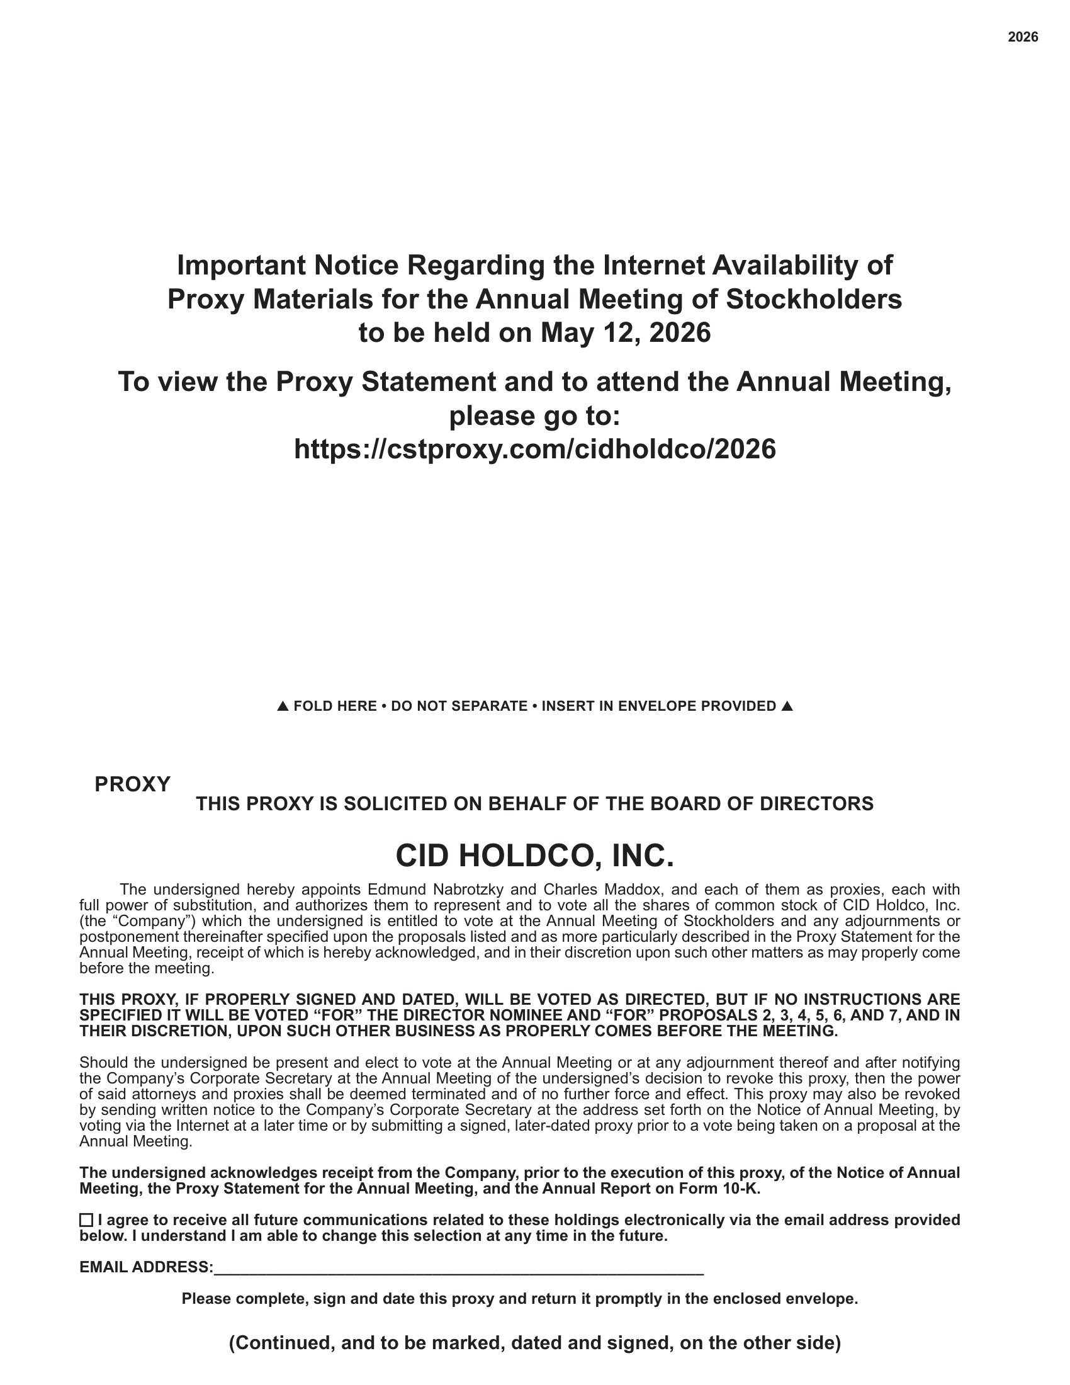
2026 FOLD HERE • DO NOT SEPARATE • INSERT IN ENVELOPE PROVIDED Important Notice Regarding the Internet Availability of Proxy Materials for the Annual Meeting of Stockholders to be held on May 12, 2026 To view the Proxy Statement and to attend the Annual Meeting, please go to: https://cstproxy.com/cidholdco/2026 PROXY THIS PROXY IS SOLICITED ON BEHALF OF THE BOARD OF DIRECTORS CID HOLDCO, INC. The undersigned hereby appoints Edmund Nabrotzky and Charles Maddox, and each of them as proxies, each with full power of substitution, and authorizes them to represent and to vote all the shares of common stock of CID Holdco, Inc . (the “Company”) which the undersigned is entitled to vote at the Annual Meeting of Stockholders and any adjournments or postponement thereinafter specified upon the proposals listed and as more particularly described in the Proxy Statement for the Annual Meeting, receipt of which is hereby acknowledged, and in their discretion upon such other matters as may properly come before the meeting . THIS PROXY, IF PROPERLY SIGNED AND DATED, WILL BE VOTED AS DIRECTED, BUT IF NO INSTRUCTIONS ARE SPECIFIED IT WILL BE VOTED “FOR” THE DIRECTOR NOMINEE AND “FOR” PROPOSALS 2 , 3 , 4 , 5 , 6 , AND 7 , AND IN THEIR DISCRETION, UPON SUCH OTHER BUSINESS AS PROPERLY COMES BEFORE THE MEETING . Should the undersigned be present and elect to vote at the Annual Meeting or at any adjournment thereof and after notifying the Company’s Corporate Secretary at the Annual Meeting of the undersigned’s decision to revoke this proxy, then the power of said attorneys and proxies shall be deemed terminated and of no further force and effect . This proxy may also be revoked by sending written notice to the Company’s Corporate Secretary at the address set forth on the Notice of Annual Meeting, by voting via the Internet at a later time or by submitting a signed, later - dated proxy prior to a vote being taken on a proposal at the Annual Meeting . The undersigned acknowledges receipt from the Company, prior to the execution of this proxy, of the Notice of Annual Meeting, the Proxy Statement for the Annual Meeting, and the Annual Report on Form 10 - K . I agree to receive all future communications related to these holdings electronically via the email address provided below. I understand I am able to change this selection at any time in the future. EMAIL ADDRESS : Please complete, sign and date this proxy and return it promptly in the enclosed envelope. (Continued, and to be marked, dated and signed, on the other side)

